Single-source automation promises a more flexible future
B&R and Hyundai Heavy Industries enter strategic partnership
B&R and Hyundai Heavy Industries (HHI) signed a global strategic partnership agreement to introduce B&R automation solutions across HHI's various areas of operation, including control solutions for ship, plant and power automation that will benefit HHI's customers in the oil and gas, shipbuilding, water treatment and other industries.
More flexibility with integrated automation platform
By establishing a consistent and integrated automation platform from a macro perspective, HHI is positioning itself to respond more flexibly to unpredictable future challenges. B&R and HHI look forward to synergies in technological cooperation as well as close collaboration in worldwide sales, service, technical support and development.
Advanced technology for future challenges
B&R's advanced technology and commitment to standards like OPC UA and IEC 61850 will help HHI meet emerging customer requirements in the areas of Industry 4.0, Smart Factory and IIoT solutions. It will also streamline compliance with the increasingly vigorous environmental regulations of the shipbuilding industry.
​B&R will provide training and support as well as engineering and technical expertise, drawing on extensive experience gained through high-profile projects with end users in various industries around the world.​

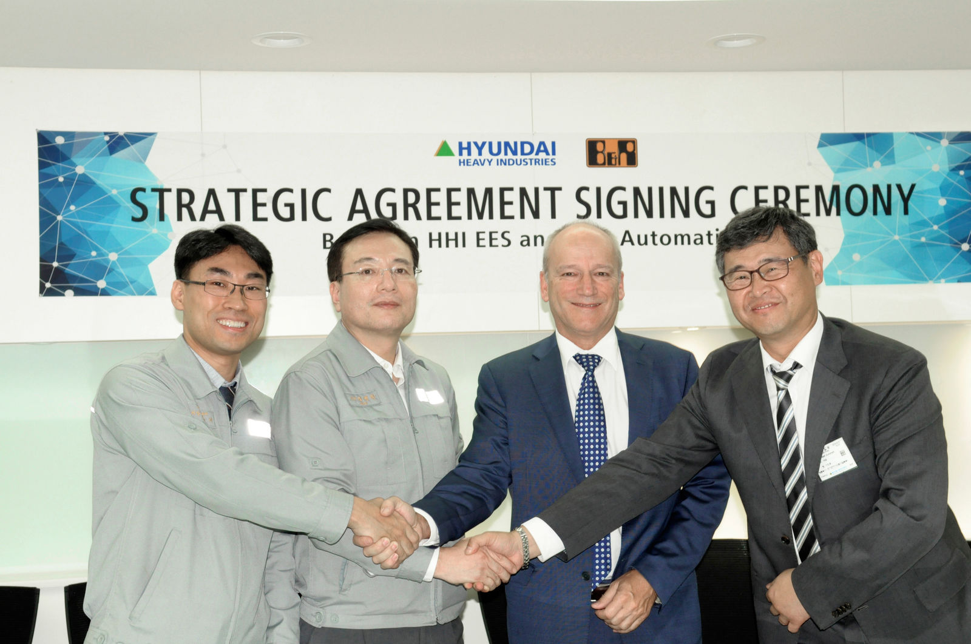
From left: Kim Dongkee (Head of Automation Solutions, HHI-EES), Choi Byeonghan (Managing Director, HHI-EES), Peter Gucher (General Manager, B&R) and Lee Yniong (Managing Director, B&R Korea) signed a global strategic partnership agreement on automation solutions.

About B&R
B&R, a division of ABB Group, is a global leader in industrial automation headquartered in Austria. B&R combines state-of-the-art technology with advanced engineering to provide customers in virtually every industry with complete solutions for machine and factory automation, motion control, HMI and integrated safety technology. With Industrial IoT communication standards including OPC UA, POWERLINK and openSAFETY as well as its Automation Studio software, B&R is constantly redefining the future of automation engineering. The innovative spirit that keeps B&R at the forefront of industrial automation is driven by a commitment to simplifying processes and exceeding customer expectations.
For more information, visit www.br-automation.com.

